A

PROJECT REPORT

ON

**ONLINE SHOPPING SYSTEM**

Towards partial fulfilment of the requirement in

**6th Semester BCA (2018-2019)**

**Submitted By: -**

Leonard HABIMANA (160510101041)

Romarick Junior AKA (170510101903)

**Submitted To: -**



**Parul Institute of Computer Application,**

**Parul University**

Under the Guidance of

Mr. JANARDAN BHARVAD,

Assistant Professor

**Acknowledgement**

*The success and final outcome of this project required a lot of guidance and assistance from many people and we are extremely privileged to have got this all along the completion of our project. All that we have done is only due to such supervision and assistance and we would not forget to thank them.*

*I respect and thank Dr. Priya Swaminarayan, Dean, FITCS for providing us an opportunity to do the project work in BCA and giving us all support and guidance which made us complete the project duly. We are extremely thankful to Mam for providing her support and guidance, although she had busy schedule managing the academic affairs.*

*We would not forget to remember Prof. Harshika Rana, HOD, BCA department for her encouragement and more over for her timely support and guidance till the completion of our project work.*

*We owe our deep gratitude to our project guide Prof Janardan Bharvad, who took keen interest on our project work and guided us all along, till the completion of our project work by providing all the necessary information for developing a good system.*

*I am thankful to and fortunate enough to get constant encouragement, support and guidance from our Parents, all Teaching staffs of BCA Department which helped us in successfully completing our project work. Also, we would like to extend our sincere esteems to all staff in laboratory for their timely support.*

***[Leonard Habimana] [160510101041]***

***[Romarick Junior Aka] [170510101903]***



**PARUL INSTITUTE OF COMPUTER APPLICATION**

**CERTIFICATE**

This is to certify that ***Leonard HABIMANA & Romarick junior AKA*** the student(s) of Parul Institute of Computer Application, has/have satisfactorily completed the project entitled “***Online Shopping System”*** as a part of course curriculum in BCA / IMCA semester-VI for the academic year 2018-2019 under guidance of ***Prof Janardan Bharvad.***

Enrollment Number: 160510101041

Enrollment Number: 170510101903

|  |  |  |
| --- | --- | --- |
| **Quality of work** | **Grade** | **Sign of Internal guide** |
| **Poor / Average / Good /**  **Excellent** | **B /B+ / A / A+** |  |

Date of submission:

HOD Principal

Prof. Harshika Rana Dr. Priya Swaminarayan

**ABSTRACT**

**O**nline shopping (sometimes known as e-tail from "electronic retail" or e-shopping) is a form of electronic commerce which allows consumers to directly buy goods or services from a seller over the Internet using a web browser. Alternative names are e-web-store, e-shop, e-store, Internet shop, web-shop, web-store, online store, online storefront and virtual store. Mobile commerce (or m-commerce) describes purchasing from an online retailer’s mobile optimized online site or app.

An online shop evokes the physical analogy of buying products or services at a bricks-and-mortar retailer or shopping centre; the process is called business-to-consumer (B2C) online shopping. In the case where a business buys from another business, the process is called business-to-business (B2B) online shopping. The largest of these online retailing corporations are Alibaba, Amazon.com, and eBay.

**INDEX**

Table of Contents

1. **RESEARCH** 1

Types of research methodology 1

Why is it useful? 2

2. **FEASIBILITY** 3

**2.1 Technical feasibility** 3

**2.2 Economic feasibility** 5

**2.3 Operational Feasibility** 5

**2.4 Schedule feasibility** 5

**3. SYSTEM REQUIREMENT SPECIFICATION (SRS)** 8

**3.1 Introduction to SRS** 8

**3.2 Abstract** 8

**3.3 System Users** 8

**3.4 Modules of online shopping system** 8

**3.5 Hardware required** 9

**3.6 Software Requirements** 9

**3.7** **Time line chart** 10

**4. TECHNOLOGY DESCRIPTION** 11

**4.1 Limitations and features** 11

**5.** **UML (Unified Modeling Language)** 13

**5.1 Class diagram** 13

**5.2Activity Diagram** 15

**5.3 Use case Diagram** 17

**6. ENTITY RELATIONSHIP DIAGRAM** 19

**6.1 Description** 19

**7. DATA DICTIONARY** 22

**7.1 Description** 22

**8.** **FORM DESIGN SCREENSHOT** 24

**9. TESTING** 27

**9.1 Importance of testing** 27

**9.2 Types of testing** 27

**9.3 Screenshots of testing phase** 28

**10. FUTURE ENHANCEMENT** 30

**11. REFERENCES & BIBLIOGRAPHY** 31

# **RESEARCH**

Research is a systematic study, inquiry or investigation that collects data and information on a specific thing like a problem! It is a form of science that turns a normal thing into a question of how it was build, where did it come from and what are the other forms it can transform into.

Research is based on finding detailed information or knowledge about a specific thing.

## Types of research methodology

There are various types of Research, but the basic ones are 6

* Basic Research
* Applied Research
* Problem Oriented Research
* Problem Solving Research
* Quantitative Research
* Qualitative Research

1. **Basic Research**

Also known as Pure or fundamental, it is based on getting knowledge on some concepts rather than creating or inventing. This research is mostly operated on human welfare, animal welfare and animal kingdom welfare.

1. **Applied Research**

This research is based on solving practical problems of the modern world, analysis and solving social and real-life problems rather than acquiring knowledge. Its goal is to improve human condition by investigating ways for using knowledge to solve practical problems life government issues.

1. **Problem Oriented Research**

This research is based on solving the problems faced by other companies by knowing the exact nature of the problem to be solved. It means if like one company faces a problem, the study looks after the cause of the problem and how to overcome it.

1. **Problem Solving Research**

This research is based on numeric figures or numbers. Quantitative research aim is to measure the quantity or amount and compares it with past records and tries to project for future period. In social sciences, “quantitative research refers to the systematic empirical investigation of quantitative properties and phenomena and their relationships”.

1. **Qualitative Research**

Qualitative research presents non-quantitative type of analysis. Qualitative research is collecting, analysing and interpreting data by observing what people do and say. Qualitative research refers to the meanings, definitions, characteristics, symbols, metaphors, and description of things. Qualitative research is much more subjective and uses very different methods of collecting information, mainly individual, in-depth interviews and focus groups.

The nature of this type of research is exploratory and open ended. Small number of people are interviewed in depth and or a relatively small number of focus groups are conducted.

## Why is it useful?

* A Tool for Building Knowledge and Efficient Learning
* Means to Understand Various Issues
* An Aid to Business Success
* A Way to Prove Lies and to Support Truth

# **FEASIBILITY**

Is a formal project document that shows results of the analysis, research and evaluation of a proposed project and determines if this project is technically feasible, cost-effective and profitable. The primary goal of feasibility study is to assess and prove the economic and technical viability of the business idea. The outcome of the study will determine if there is economic sense to take the project initiative and proceed with the development of the implementation plan.

It focuses on these major questions:

1. What are the user’s demonstrable needs and how does a system meet them?

2. What resources are available for given system?

3. What are the likely impacts of the system on the organization?

4. Whether it is worth to solve the problem?

**Steps involved in the feasibility analysis are:**

* Form a project team and appoint a project leader.
* Prepare system flowcharts.
* Enumerate potential proposed system.
* Define and identify characteristics of proposed system.
* Determine and evaluate performance and cost effective of each proposed system.
* Weight system performance and cost data.
* Select the best-proposed system.
* Prepare and report final project directive to management.

## **2.1 Technical feasibility**

A study of resource availability that may affect the ability to achieve an acceptable system. This evaluation determines whether the technology needed for the proposed system is available or not.

* Can the work for the project be done with current equipment existing software technology& available personal?
* Can the system be upgraded if developed?
* If new technology is needed, then what can be developed?
* This is concerned with specifying equipment and software that will successfully satisfy the user requirement.

The technical needs of the system may include:

Front-end and back-end selection

An important issue for the development of a project is the selection of suitable front-end and back-end. When we decided to develop the project, we went through an extensive study to determine the most suitable platform that suits the needs of the organization as well as helps in development of the project. The aspects of our study included the following factors.

**Front-end selection:**

1. It must have a GUI that assists employees that are not from IT background.
2. Scalability and extensibility.
3. Flexibility.
4. Robustness.
5. According to the organization requirement and the culture.
6. Must provide excellent reporting features with good printing support.
7. Platform independent.
8. Easy to debug and maintain.
9. Event driven programming facility.
10. Front end must support some popular back end like Ms. Access. According to the above stated features we selected xml as the front-end for developing our project.

**Back-end Selection:**

1. Multiple user support.
2. Efficient data handling.
3. Provide inherent features for security.
4. Efficient data retrieval and maintenance.
5. Stored procedures.
6. Popularity.
7. Operating System compatible.
8. Easy to install.
9. Various drivers must be available.
10. Easy to implant with the Front-end.

Hence, we can say that the proposed system is technically feasible.

## **2.2 Economic feasibility**

Economic justification is generally the “Bottom Line” consideration for most systems. Economic justification includes a broad range of concerns that includes cost benefit analysis. The financial and the economic questions during the preliminary investigation are verified to estimate the following:

* The proposed system will give the minute information, as a result the performance is improved.
* This feasibility checks whether the system can be developed with the available funds. The Online Shopping System does not require enormous amount of money to be developed.

Hence, we can say that the proposed system is economically feasible.

## **2.3 Operational Feasibility**

It is mainly related to human organizations and political aspects. The points to be considered are:

* What changes will be brought with the system?
* What organization structures are disturbed?
* What new skills will be required? Do the existing staff members have these skills? If not, can they be trained in due course of time? The system is operationally feasible as it very easy for the End users to operate it. It only needs basic information about Windows platform.

Hence, we can say that the proposed system is operationally feasible.

## **2.4 Schedule feasibility**

Time evaluation is the most important consideration in the development of project. The time schedule required for the developed of this project is very important since more development time effect machine time, cost and cause delay in the development of other systems. A reliable

Online Shopping System can be developed in the considerable amount of time

**SDLC (System Development Life Cycle)**

SDLC is a process followed for a software project, within a software organization. It consists of a detailed plan describing how to develop, maintain, replace and alter or enhance specific software. The life cycle defines a methodology for improving the quality of software and the overall development process.

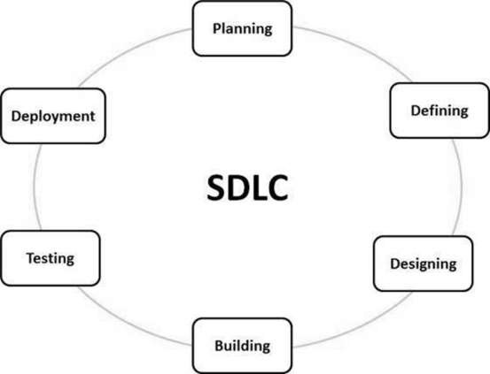The following figure is a graphical representation of the various stages of a typical SDLC.

A typical Software Development Life Cycle consists of the following stages: -

1. Stage 1: Planning and Requirement Analysis
2. Stage 2: Defining Requirements
3. Stage 3: Designing the Product Architecture
4. Stage 4: Building or Developing the Product
5. Stage 5: Testing the Product
6. Stage 6: Deployment in the Market and Maintenance

**Requirement gathering**

It is need of information for system creation.

About Online Shopping System:

* Here in this system need to keep records of customers and admin, which will help to create outlet of system, and manage data through database.

**Design**

Design of the system is created through various diagrams. DFD, flowchart etc. Which helps to design system step by step.

About Online Shopping System:

* Refer to UML we will design this system in a way that will be attracting and be effective to users.

**Implementation**

Here all the collected resources and data is used in most effective manner. Implementation helps to find if something is error or difficulties in our current system.

**Testing**

After implementation testing is done on website, which analyses all the modules working. If all the requirements are met of customer as well as of admin than testing phase is over.

About Online Shopping System:

* We will provide this system to any single buyer.

**Maintenance**

On regular basis maintenance is done to update the system. It also repairs the fault if found during run of the system. And if still in system is down then some elements are to be replaced.

About Online Shopping system:

* From feedbacks, we might provide some versions of this system
* Some security checkups after a month.
* If server breaks down, new one is to be brought.

# **3. SYSTEM REQUIREMENT SPECIFICATION (SRS)**

## **3.1 Introduction to SRS**

A software requirements specification (SRS) is a comprehensive description of the intended purpose and environment for software under development. The SRS fully describes what the software will do and how it will be expected to perform.

The SRS is technical specification of requirement of Online Shopping System. This specification describes what the proposed system should do without describing how it will do it. It also describes complete external behaviour of proposed system.

## **3.2 Abstract**

The present system make shopping task easy and is to develop software that replaces the manual shopping system into automated online shopping system.

## **3.3 System Users**

* **Admin-**
* Admin will have full access to the system
* Manage the products by changing the previous information to the current details.
* Generate the reports after some estimated time.
* **Customer-**
* Customers can access the system by registering or login if they are already registered or enter as a guest means he/she doesn’t need to create an account.
* Then after the customer can search the products according to his/her need.

## **3.4 Modules of online shopping system**

* **Registration/Login**
  + Customers can register and login to the system anytime to have an account where they can check their bookings so easy and book new tickets easily without filling their details again.
* **Checkout**
* This is a part of **online shopping** in which the customer enters delivery information and pays for the items, You may choose to pay for your order online using our secure checkout.
* **Account**
  + This is account that display all the details of the on your system.
* **Payment**
* This means to allow a number of potential buyers to shop at your site and get their goods almost immediately by paying the products bought by buyer.
* **Search Engine Optimization (SEO)**
* This is the process that enable shoppers to use "**search**" features to find specific models, brands or items
* **Product browsing**
* Online shopping allows you to set up categories structure and product page to suit your business.

## **3.5 Hardware required**

You will need a PC with an Internet connection.

System configuration:

* configuration
  + 1GB ram
  + 1.2 GHz processor
  + 100 MB free harddisk and above

## **3.6 Software Requirements**

Internet Browser such as Internet Explorer 6.0 and higher or another browser of the same generation is required to access the application

* configuration
* Windows 7 or higher
* Wamp server
* Google chrome(any browser)

## **Time line chart**

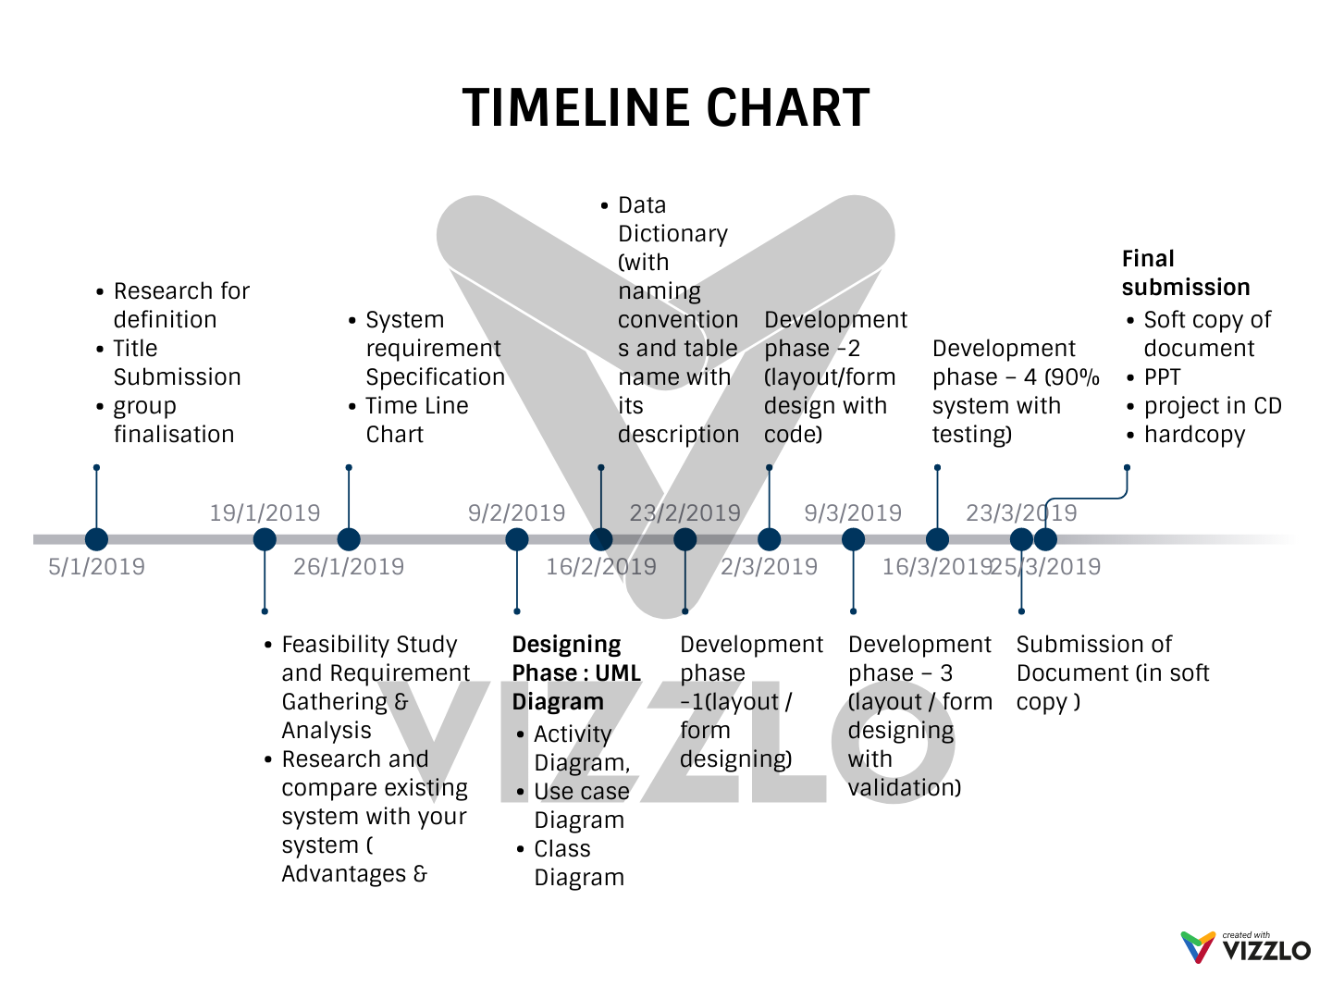

# **4.** **TECHNOLOGY DESCRIPTION**

* PHP:
* PHP is an acronym for "PHP: Hypertext Preprocessor"
* PHP is a widely-used, open source scripting language
* PHP scripts are executed on the server
* PHP is free to download and use
* MySQL:
* MySQL is the most popular Open Source Relational SQL Database Management System.
* MySQL is one of the best RDBMS being used for developing various web-based software applications. MySQL is developed, marketed and supported by MySQL AB, which is a Swedish company.
* CSS:
* CSS stands for Cascading Style Sheets
* CSS describes how HTML elements are to be displayed on screen, paper, or in other media
* CSS saves a lot of work. It can control the layout of multiple web pages all at once.
  + J-query:
  + jQuery is a lightweight, "write less, do more", JavaScript library.
  + The purpose of jQuery is to make it much easier to use JavaScript on your website.

## **4.1 Limitations and features**

Limitations:

1. Delay in delivery

2. Lack of significant discounts in online shops

3. Lack of touch and feel of merchandise in online shopping

4. Lack of interactivity in online shopping

Features:

1 Ease of Use.

2 Related Items.

3 User Reviews.

4 High Resolution Photo

5 Security

6 SEO.

7 SocialMediaIntegration.

# **UML (Unified Modeling Language)**

The Unified Modeling Language (UML) is a standard visual modeling language intended to be used for modeling business and similar processes, analysis, design, and implementation of software-based systems. UML is a common language for business analysts, software architects and developers used to describe, specify, design, and document existing or new business processes, structure and behavior of artifacts of software systems.

UML can be applied to diverse applicationdomains (e.g., banking, finance, internet, aerospace, healthcare, etc.) It can be used with all major object and component software development methods and for various implementation platforms (e.g., J2EE, .NET).

## **5.1 Class diagram**

**Description of Class diagram**

Class diagram is a static diagram. It represents the static view of an application. Class diagram is not only used for visualizing, describing, and documenting different aspects of a system but also for constructing executable code of the software application.

Class diagram describes the attributes and operations of a class and also the constraints imposed on the system. The class diagrams are widely used in the modeling of object-oriented systems because they are the only UML diagrams, which can be mapped directly with object-oriented languages.

Class diagram shows a collection of classes, interfaces, associations, collaborations, and constraints. It is also known as a structural diagram.

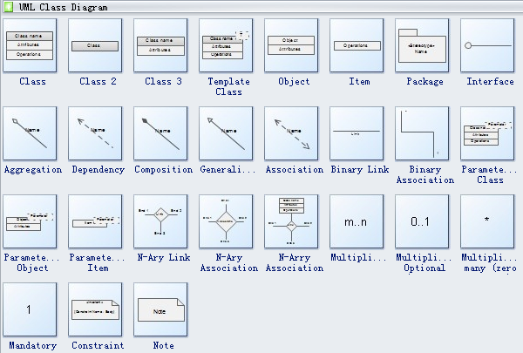

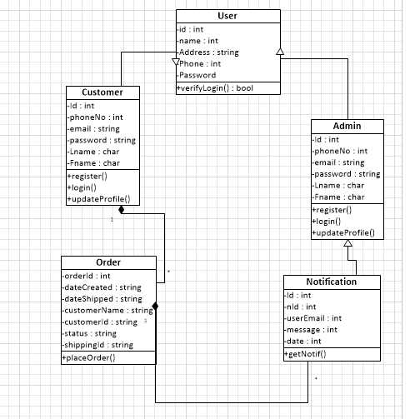

Diagram1: Class diagram

## **5.2Activity Diagram**

**Description of Activity diagram**

Activity diagram is another important diagram in UML to describe the dynamic aspects of the system. Activity diagram is basically a flowchart to represent the flow from one activity to another activity. The activity can be described as an operation of the system.

The control flow is drawn from one operation to another. This flow can be sequential, branched, or concurrent. Activity diagrams deal with all type of flow control by using different elements such as fork, join, etc.

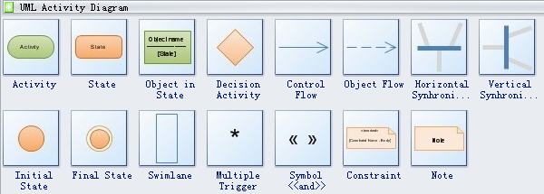

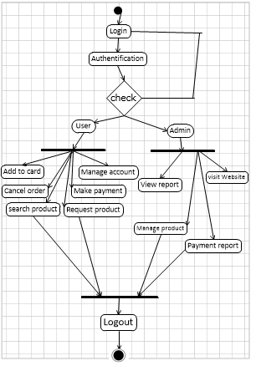

Diagram 2 : Activity diagram

## **5.3 Use case Diagram**

**Description of Use case diagram**

To model a system, the most important aspect is to capture the dynamic behavior. Dynamic behavior means the behavior of the system when it is running/operating.

Only static behavior is not sufficient to model a system rather dynamic behavior is more important than static behavior. In UML, there are five diagrams available to model the dynamic nature and use case diagram is one of them. Now as we have to discuss that the use case diagram is dynamic in nature, there should be some internal or external factors for making the interaction.

These internal and external agents are known as actors. Use case diagrams consists of actors, use cases and their relationships. The diagram is used to model the system/subsystem of an application. A single use case diagram captures a particular functionality of a system.

Hence to model the entire system, several use case diagrams are used.

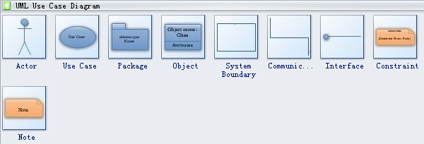

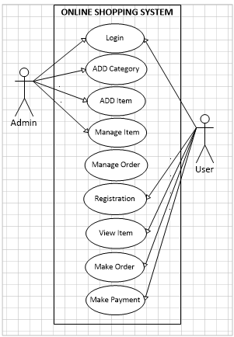

Diagram 3 : Use case diagram

# **6. ENTITY RELATIONSHIP DIAGRAM**

## **6.1 Description**

An ER Diagram contains entities, attributes and relationships. In this section we will go through the ERD symbols in detail.

**Entity**

An ERD entity is a **definable thing or concept within a system**, such as a person/role (e.g. Student), object (e.g. Invoice), concept (e.g. Profile) or event (e.g. Transaction) (note: In ERD, the term "entity" is often used instead of "table", but they are the same).

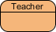

**Entity Attributes**

Also known as column, an attribute is a **property or characteristic of the entity that holds it**.

An attribute has a name that describes the property and a type that describes the kind of attribute it is, such as varchar for a string, and int for integer. When an ERD is drawn for physical database development, it is important to ensure the use of types that are supported by the target RDBMS.

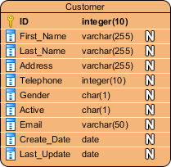

**Primary Key**

Also known as PK, a primary key is a special kind of entity attribute that **uniquely defines a record in a database table**

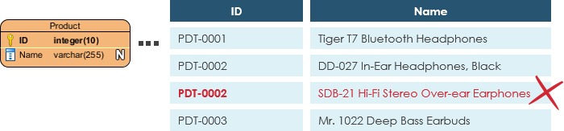

**Foreign Key**

Also known as FK, a foreign key is a **reference to a primary key in table**. It is used to identify the relationships between entities. Note that foreign keys need not to be unique. Multiple records can share the same values

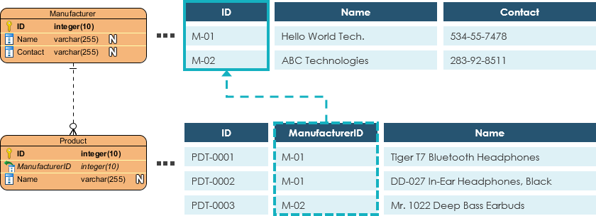

**Relationship**

A relationship between two entities signifies that the two entities are associated with each other somehow

**Cardinality**

Cardinality defines the possible number of occurrences in one entity which are associated to the number of occurrences in another. For example, ONE team has MANY players. When present in an ERD, the entities Team and Player are inter-connected with a one-to-many relationship.

In an ER diagram, cardinality is represented as a crow's foot at the connector's ends. The three common cardinal relationships are one-to-one, one-to-many, and many-to-many.

One-to-One cardinality example

A one-to-one relationship is mostly used to split an entity in two to provide information concisely and make it more understandable. The figure below shows an example of one-to-one relationship.

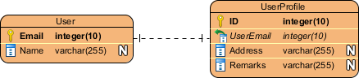

One-to-Many cardinality example

A one-to-many relationship refers to the relationship between two entities X and Y in which an instance of X may be linked to many instances of Y, but an instance of Y is linked to only one instance of X. The figure below shows an example of one-to-many relationship.

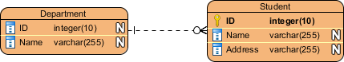

Many-to-Many cardinality example

A many-to-many relationship refers to the relationship between two entities X and Y in which X may be linked to many instances of Y and vice versa. The figure below shows an example of many-to-many relationship. Note that a many-to-many relationship is split into a pair of one-to-many relationships in a physical ERD. You will know what a physical ERD is in the next section.

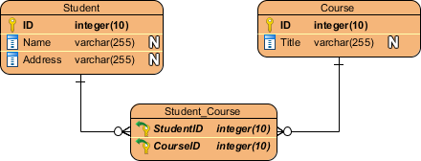

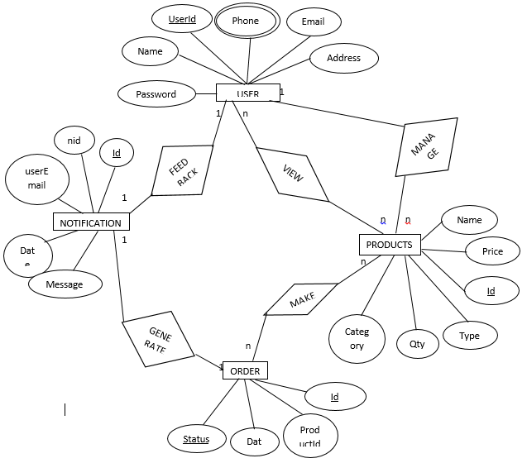

Diagram 4 : ER diagram

# **7. DATA DICTIONARY**

## **7.1 Description**

A **data dictionary**, or metadata repository, as defined in the IBM Dictionary of Computing, is a "centralized repository of information about data such as meaning, relationships to other data, origin, usage, and format". Oracle defines it as a collection of tables with metadata. The term can have one of several closely related meanings pertaining to databases and database management systems (DBMS):

* A document describing a database or collection of databases
* An integral component of a DBMS that is required to determine its structure
* A piece of middleware that extends or supplants the native data dictionary of a DBMS

**List of Tables and their Descriptions**

|  |  |  |  |  |
| --- | --- | --- | --- | --- |
| Entity | Constraints | Attributes | Datatypes | Size |
| User | Primary Key  Non-Null  Non-Null  Non-Null  Non-Null  Non-Null  Non-Null | User ID  FName  LName  Phone Number  Email  Username  Password | AutoNumber  Varchar  Varchar  Number  Varchar  Varchar  Varchar | Auto  100  100  20  100  100  100 |
| Notification | Primary Key  Non-Null  Non-Null  Non-Null  Non-Null | Id  nId  userEmail  message  date | AutoNumber  Varchar  Varchar  Varchar  Varchar | Auto  200  200  200  200 |
| Order | Primary Key  Non-Null  Non-Null  Non-Null  Non-Null  Non-Null | Id  orderId  email  productId  date  status | AutoNumber  Varchar  Varchar  Varchar  Varchar  Varchar | Auto  250  250  250  250  250 |
| Product | Primary Key  Non-Null  Non-Null  Non-Null  Non-Null  Non-Null  Non-Null  Non-Null | Productid  Product Code  Fandom  Categories  Product Image Name  Product Name  Price  Product Qty | AutoNumber  Varchar  Varchar  Varchar  varchar  Varchar  Number  Number | Auto  50  50  50  50  50  50  50 |

# **FORM DESIGN SCREENSHOT**

1. **Login Form**: This form describes how a Customer or admin will access the system according to their password and username. This form is describing new register to the system as a Customer. 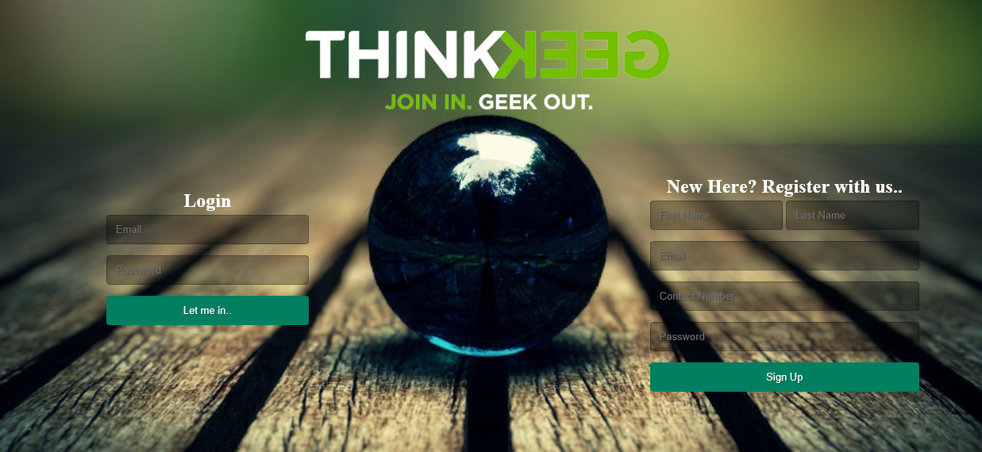

Fig.1 Login form

1. **Admin Profile:** This is the Dashboard of the Admin in the System who’s function as the build he can manager all the account in the system and give an access on it, He can access Visit website and View Inventory.

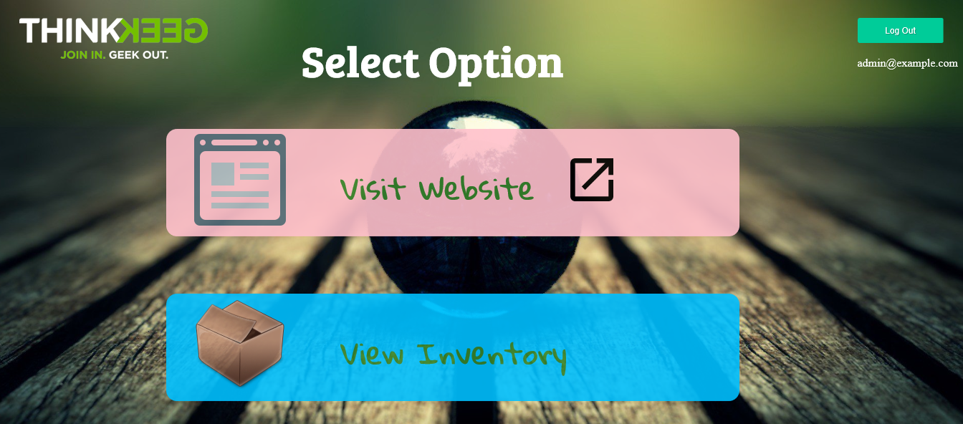

Fig.2 Admin dashboard

1. **Adding New Item:** This form is for the admin of the system which is used for inserting/ Adding new product in the store.

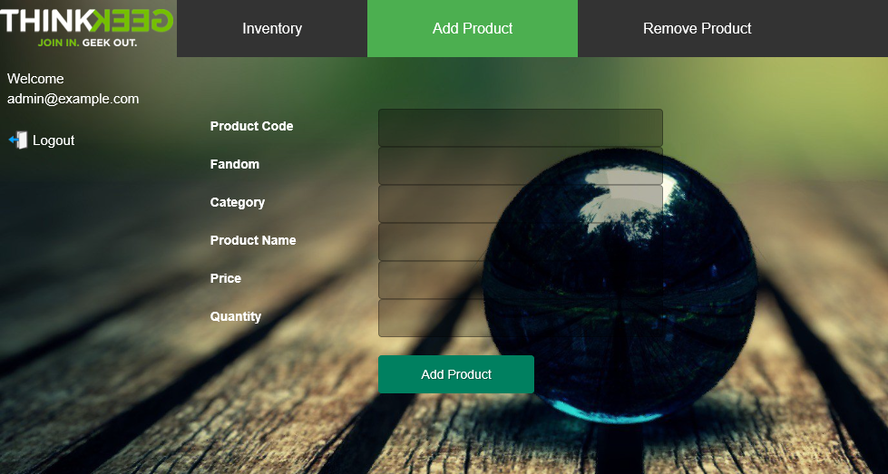

Fig.3 Adding new item

1. **Product Search:** This is the Dashboard of searching the items in system! 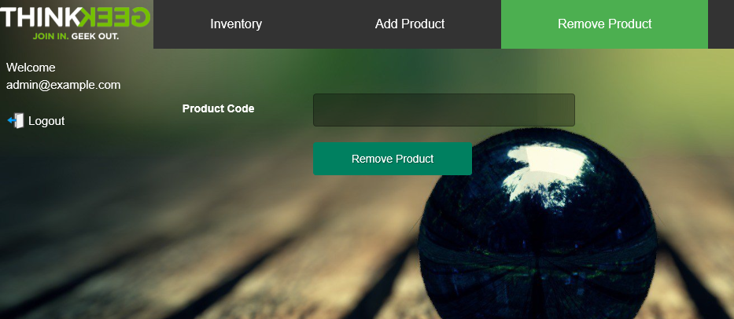

Fig.4 Searching

1. **Customer Dashboard:** This is the page that Customer of the system is going to access which are containing Different brand of the products.

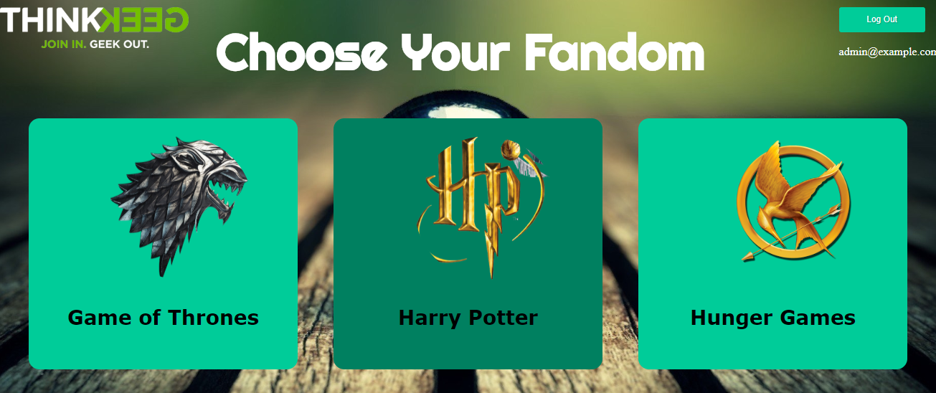

Fig.5 Customer dashboard

1. **Modules Page:** This Page describe the modules of the customer and all accessibility stuff on the system.

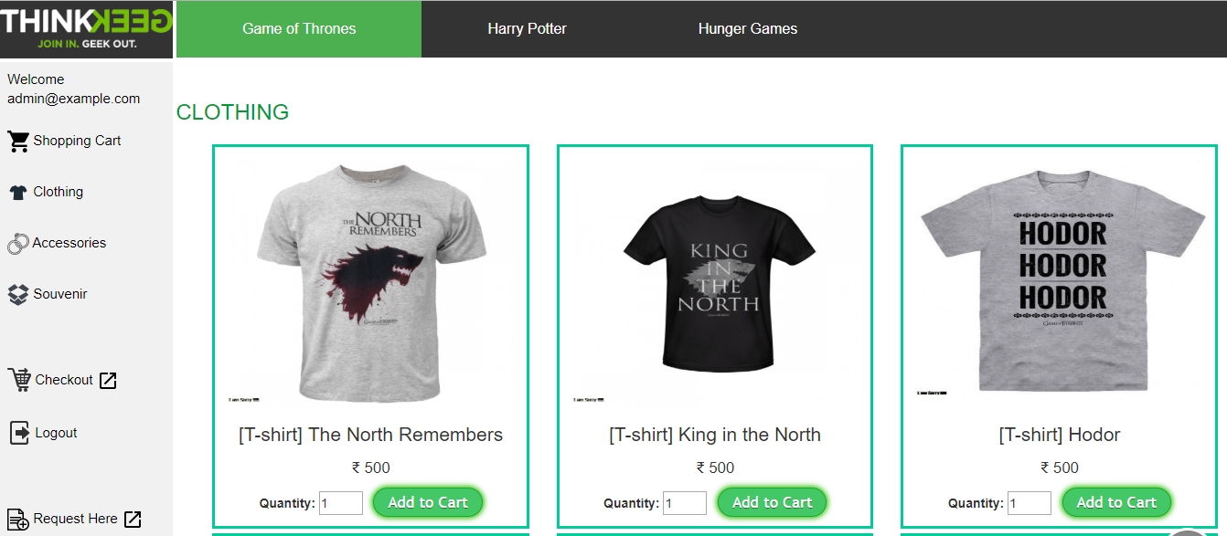

Fig.6 Module

# **9. TESTING**

## **9.1 Importance of testing**

Testing should be introducing in the early stage of the SDLC, The cost of fixing the bug is larger if testing is not done in early stage & bugs found in later stages.

In the today’s competitive market only the quality product stays long time firmly, so to make sure the produce the good quality product the testing of application is key factor in SDLC.

As it not possibly makes it software application is defect free but testing will be necessary.

Most important thing of testing is the development environment is different than the Testing environment and the testing done on testing environment is similar to the Production environment.

## **9.2 Types of testing**

-Functional testing

-Non-functional testing

**Functional testing**

**Unit testing:** Unit Testing allows your find more bugs at code level or more refined class level. Whatever you are developing Unit testing applies there, be it a web application or mobile app development. It is a concept that is up to the discretion of the team whether to use it or not.

**Integration Testing:** In integration testing, every element is treated as an atomic unit or as a black-box, at the same time the interconnections among them are checked and modelled to conduct software testing of component interfaces and interplays.

**Interface testing:** Verify that communication between the systems are done correctly if all supported hardware/software has been tested. If all linked documents are supported/opened on all platforms the security requirements or encryption while communication happens between systems. Check if a Solution can handle network failures between a Web site and application server.

**System testing:** System testing is the testing of a complete and fully integrated software product. System testing simulates real life scenarios that occur in a simulated real life test environment. It tests all the functions of the system.

**Regression testing**: User Acceptance Testing which means agreement or approval. It is used to ensure that the software is satisfying the functional and performance requirement of the end user.

**Non-functional testing**

It is a testing to determine the performance of the system to major the measure, validate or verify quality attribute of the system.

**Documentation testing**: Documentation testing helps to estimate testing efforts required and test coverage. Software documentation includes test plan, test cases, and requirements section.

**Installations testing**: Installation testing is a type of quality assurance work in the software industry that converges on what customers will need to do to install and set up the new software successfully. The testing process may involve full, partial or upgrades install/uninstall processes.

**Reliability testing:** Reliability testing assures that the product is fault free and is reliable for its intended purpose. It is about exercising an application so that failures are discovered before the system deployed.

**Security testing:** Security word itself defines that something has to relate with technique to strengthen the security. It’s not about securing data and information. It can affect to whole functionality of the system. Security testing is a variant of software testing which ensures that system and applications in an organization are free from loopholes. Security testing is about to find all possible weaknesses of the system which might result in a loss of information at the hands of the employees.

## **9.3 Screenshots of testing phase**

**Testing Phase** will check allow the users to access the system by using their correct username and password while the Password and Username is incorrect the system will produce an error message for correcting both.

Down here, it’s happened when a user pressed the login button without entering the Use id and Password and receive the error message for required field!

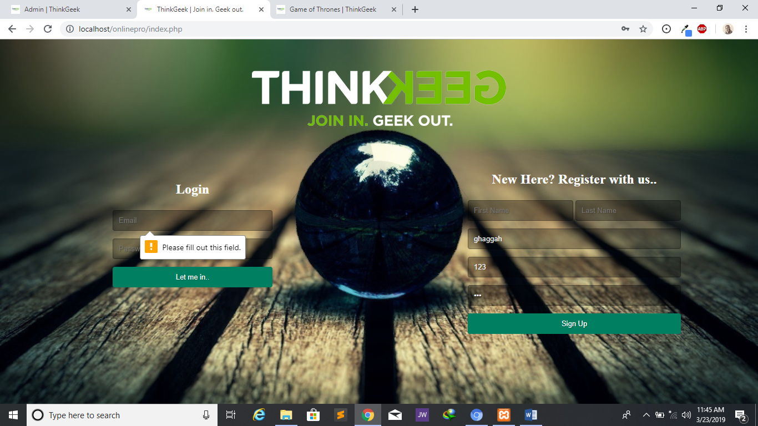

Fig.7 Login Testing

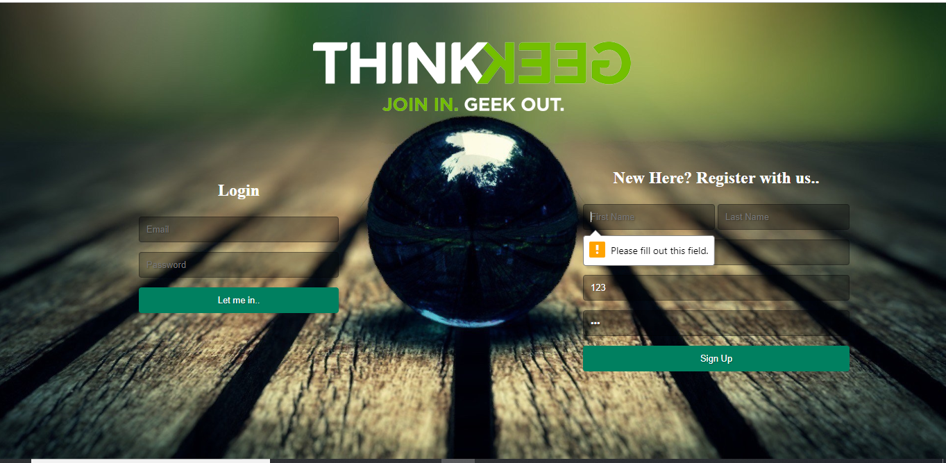

Fig.8 Registration testing

# **10. FUTURE ENHANCEMENT**

The proposed system is Online shopping System, so that for the future Enhancement will be:

* making an android Application
* shipping of the products to be tracked by the Customers
* Online payment

# **11. REFERENCES & BIBLIOGRAPHY**

**Website**

1. <http://www.w3schools.com/>.
2. <http://www.javatpoint.com>

**Books**

1. Matthew MacDonald, "Creating a Website - The Missing Manual", 3rd ed, 2011, O’Reilly.   
   (A good introductory book on HTML/CSS. A new version is expected in July 2015.)
2. Matthew MacDonald, "HTML 5 - The Missing Manual", 2nd ed, 2014, O’Reilly.
3. David Sawyer McFarland, "CSS 3 - The Missing Manual", 3rd ed, 2013, O’Reilly.